***PROJECT REPORT***

**TITLE NAME**:

***CHARTING THE COURSE OF INNOVATION: A STARTUP ANALYSIS***

# **1. INTRODUCTION:**

## 1.1. OVERVIEW:

A startup refers to a new business venture that is either owned by one person or several people. Startup generate most of their startup capital by using varies private forms of funding, and they must prove the merit of their business ideas to attract these investors.

Startup India is a government of India flagship initiative to build startups and nurture innovation.

1.2. PURPOSE:

The primary aim is to answer market demand by creating new and innovative product or services. While most small business might intend to stay small, a startup focuses on fast growth in a designated market. Usually, such companies start as and idea and gradually grow into a viable product, service or platform.

**2. PROBLEM DEFNITION**:

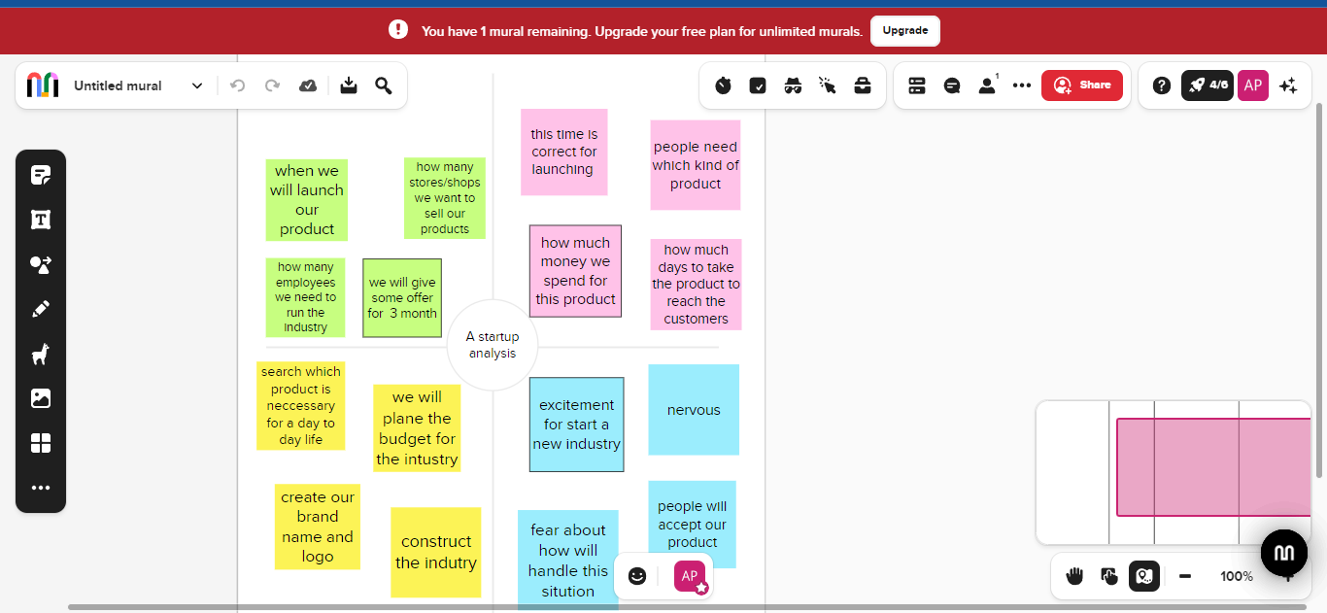

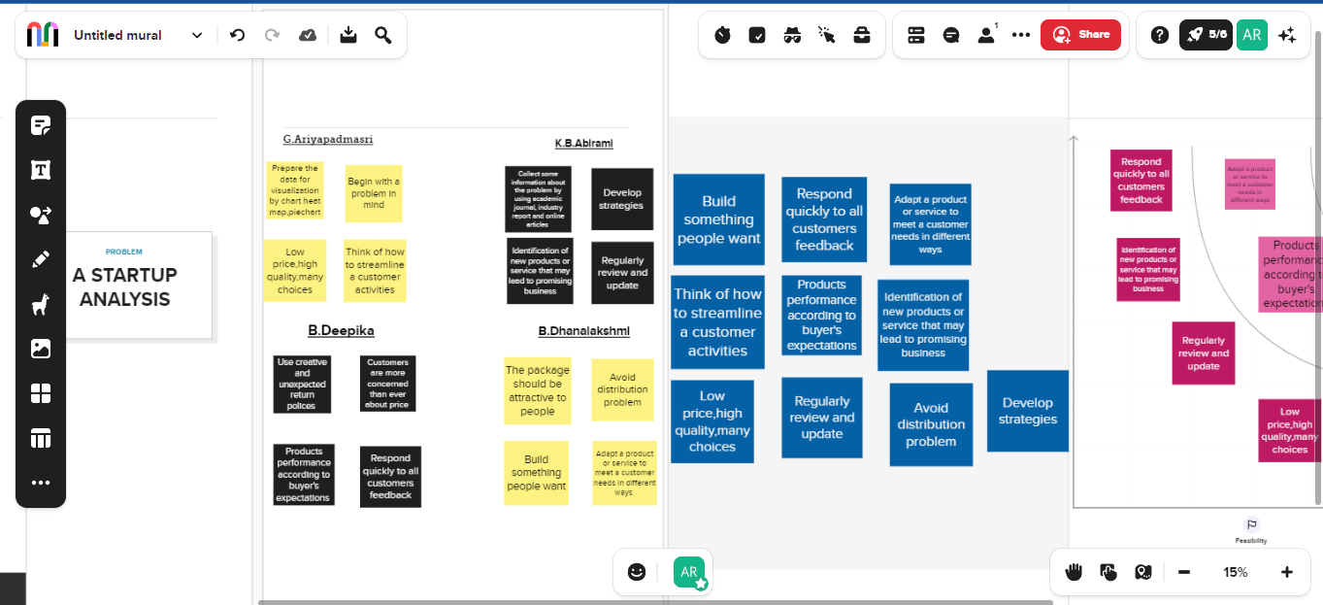

**3. RESULT:**

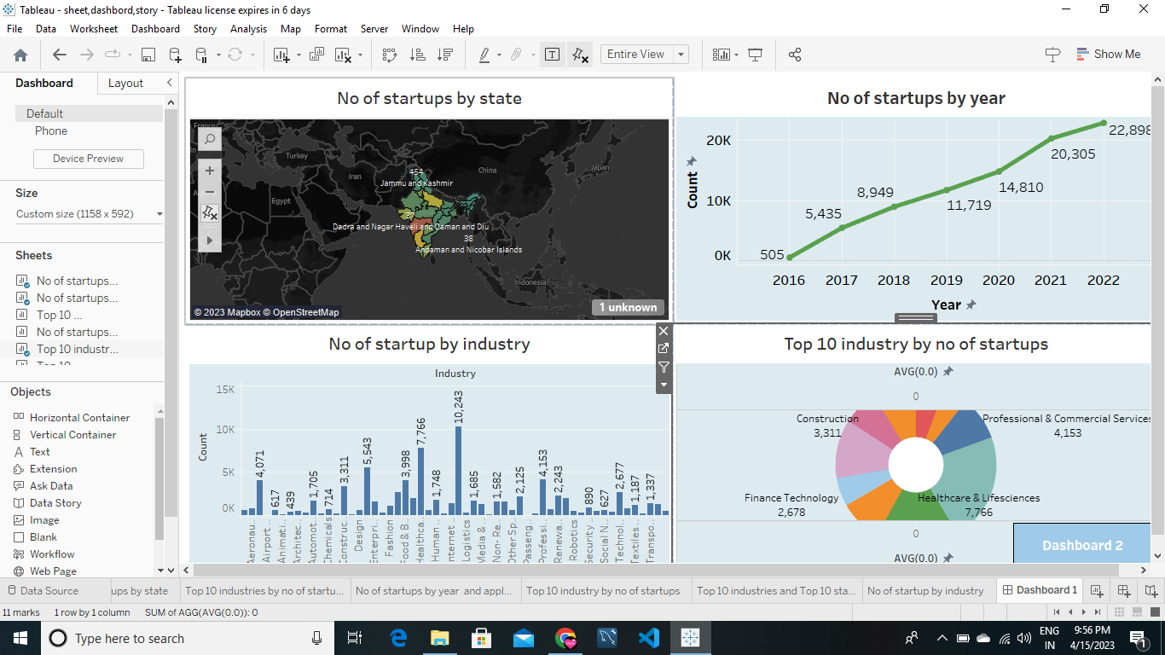

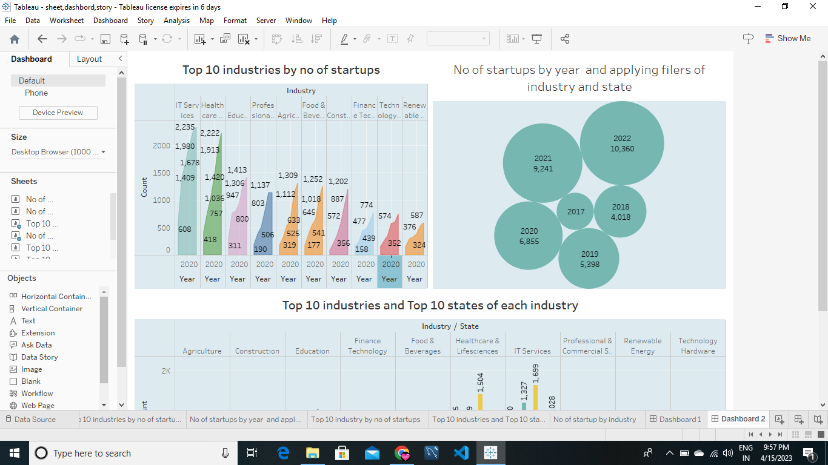

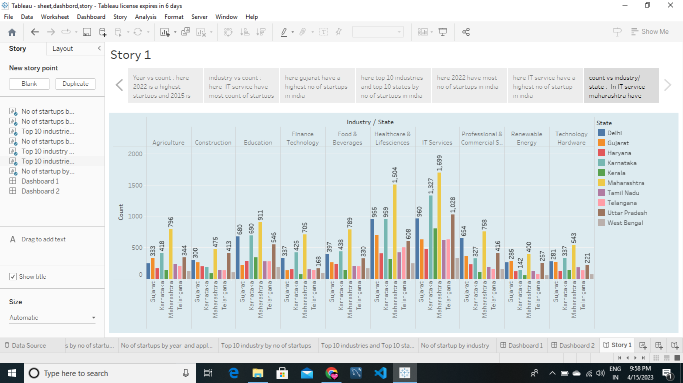

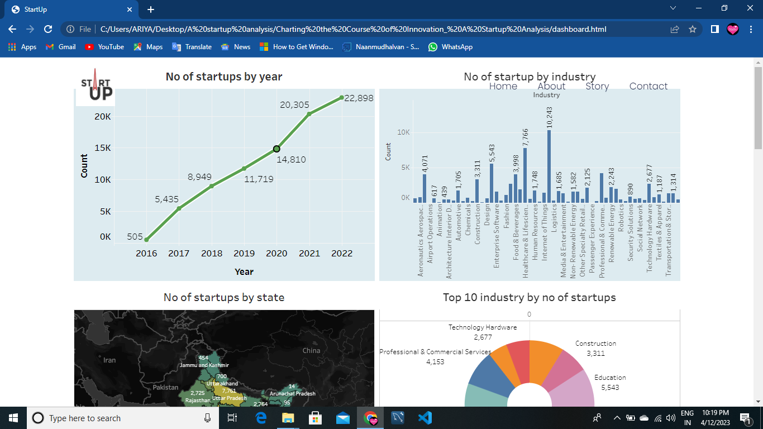

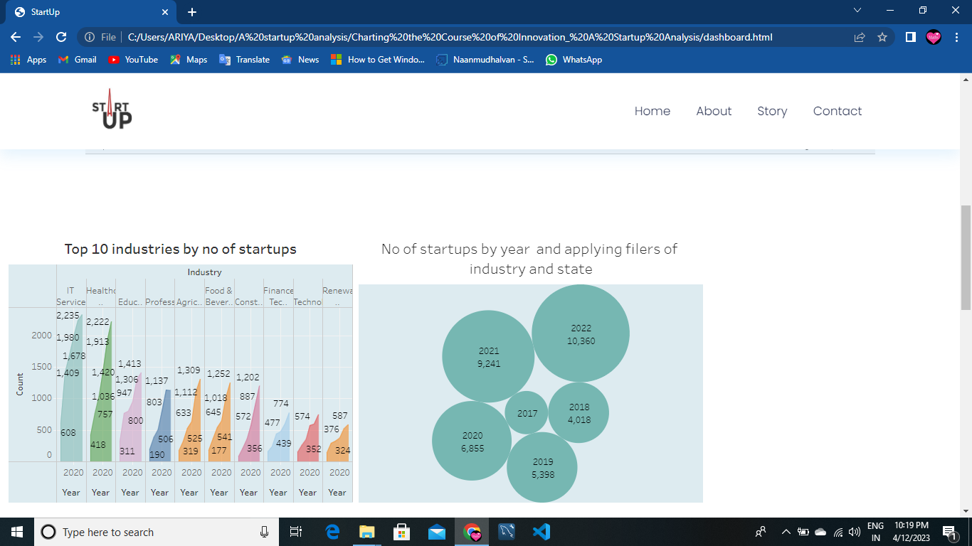

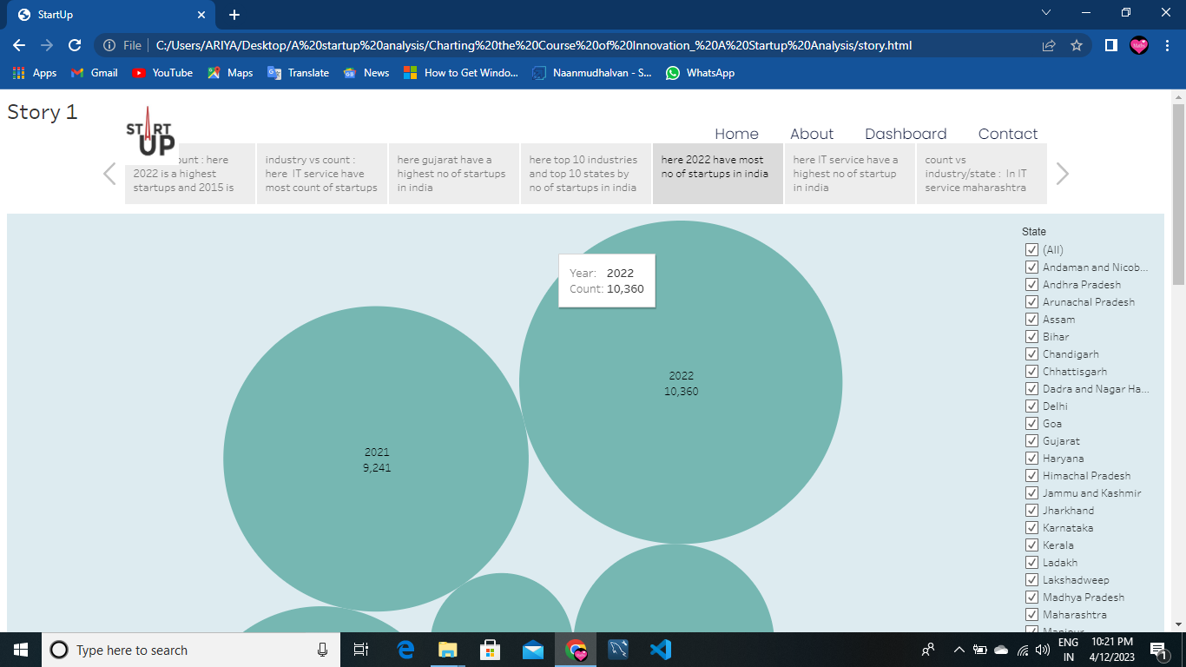

**4. ADVANTAGES & DISADVANTAGES:**

4.1. ADVANTAGES**:**

* **Lower startup cost –** depending on the type of business you start costs may be lower than a franchise where there is no upfront purchasing fee or supply costs.
* **Independence –** you make all decisions and create all business systems.
* **Site selection –** you choose where to locate your business and what marketing producers to follow

4.2. DISADVANTAGES**:**

* **High risk –** success depends totally on you and your business talents.
* **High commitment –** starting your own business requires a higher commitment of time and energy.
* **Limited financing –** financing for a new business is more difficult to obtain

**5. APPLICATIONS:**

* To starting a new business means you have the opportunity to hire to train and those who have had the opportunity for decent work in the past.
* It helps you to think different way and develop database culture.
* It helps you to engage in learn planning and understand your margins.

**6. CONCLUSION:**

In present times startups in India are witnessing a golden chapter in the history of Indian entrepreneurship. However, still the Indian government has a crucial role to play in positioning India as the Tech Garage of the World.

**7.FUTURE SCOPE:**

The number of startups rose from 471 in 2016 to 72,993 in 2022 and created more than 7,00,000 jobs by March 2022. India has become the third-largest startup ecosystem in the world after the US and China, per the Economic Survey 2021–22. Indian startups raised USD19.3 billion across 1,456 deals in Venture Capital (VC) between January 2021 and October 2021, against USD27.5 billion across 1,355 deals between January 2022 and October 2022. In addition, startups in India are expected to raise USD180 billion in 2023.

**BY**

1. **G. ARIYAPADMASRI,**
2. **K.B. ABIRAMI,**
3. **B. DEEPIKA,**
4. **B. DHANALAKSHMI.**